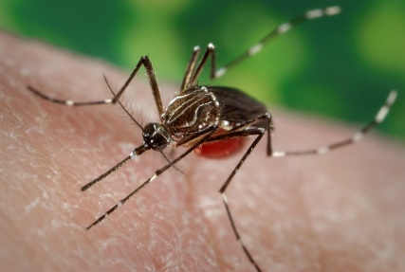 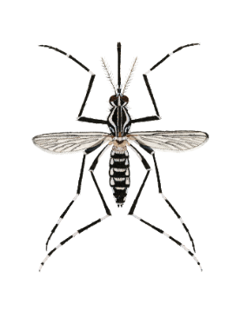

Now ESTABLISHED

*Ae. aegypti*

(Yellow fever mosquito)

“Ankle-biter”

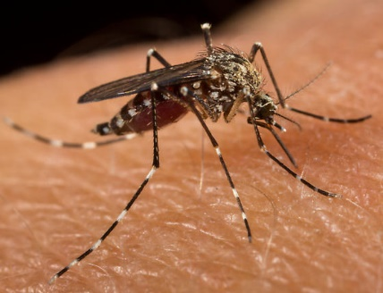

*Ae. sierrensis*

(Treehole mosquito)

Native

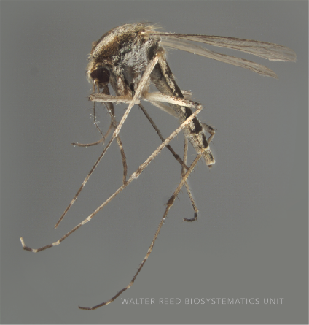

Native

*Ae. melanimon*

(Floodwater mosquito)

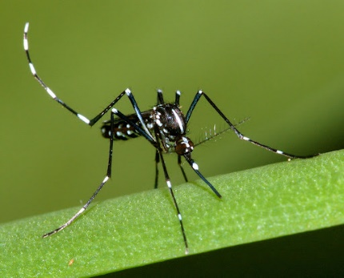 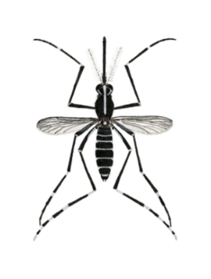

WATCH OUT

*Ae. albopictus*

(Asian tiger mosquito)

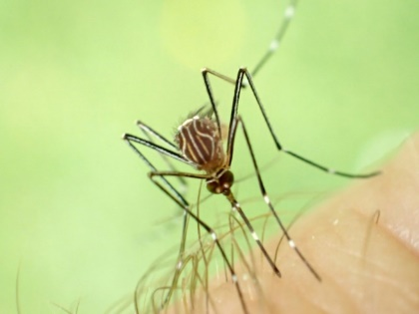 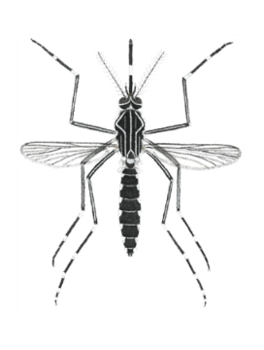

WATCH OUT

*Ae. notoscriptus*

(Australian backyard mosquito)